CS 11A: Technology & Computing Components I
H0S04A - Lists, Tuples, and Strings

Developed by Kim Nguyen on 10/10/2020
Reviewed by Sumit K C on 06/11/2026
Reviewed by Clark Ngo on 08/13/2026

School of Technology and Computing (STC) @City University of Seattle (CityU)


Before You Start
- Screenshots may be different from your environment.
- The directory path shown in screenshots may be different from yours.
- Version numbers may not match the most current version at the time of writing. If given the option to choose between the stable release (long-term support) or the most recent, please select the stable release rather than the beta-testing version.
- The steps might have subtle discrepancies. Please use your best judgment while following this cookbook-style tutorial to complete each step.
- All the steps and concepts in this tutorial are from references, so if you encounter problems, please try to read and compare the references to solve the problem. If you still can't solve the problem, please get in touch with your course's Student Assistant.
- Avoid copying code from the book or the GitHub repository. Instead, type out the code yourself. Resort copying only when you are stuck and find things that are not working as expected.
- Some steps may not be explained in detail. If you are not sure what to do:
  - Consult the resources for the course.
  - If you cannot solve the problem after a few tries (usually 15 -30 minutes), ask a Student Assistant for help.

Learning Outcomes:
Students will be able to understand:
- Section 1: Lists and Tuples in Python

Resources
- Python crash course: a hands-on, project-based introduction to programming: Matthes, E. (2023)

Section 1: Lists and Tuples in Python
- Lists
A List is a versatile datatype available in Python. It can be written as a list of comma-separated values (items) between square brackets. The important thing about a list is that items need not be the same type.
Creating a list is as simple as putting different comma-separated values between square brackets.

- Creating, accessing, and updating values

- Under the root directory, create a file called List_basic.py and type the following code.

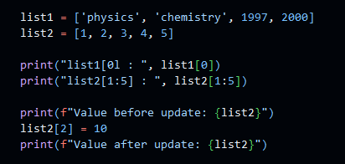

To access values in lists, use the square brackets for slicing along with the index or indices to obtain the value available at that index. Python considers the first item in a list to be at position 0, not position 1.

- Run the program to check the output of the above code.

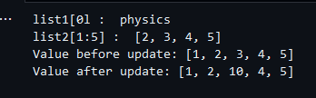

- Adding Single-Line Comment
In Python, comments are used to explain code, improve readability, or temporarily disable code during debugging. The interpreter does not execute them.

- Starts with a # symbol.
- Python ignores everything after # on that line.

# This is a single-line comment
x = 10 # This sets x to 10

Add comments on each line of code in List_basic.py to explain how each line works.

- Adding elements using Append
The most straightforward way to add a new element to a list is to append the item to the list. When you append an item to a list, a new element is added to the list. The append() method makes it easy to build lists dynamically.

- In the same file, List_basic.py, add the code below.

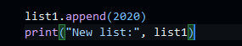

- Run the program to check the output of the above code

- Adding elements using Insert
You can add a new element to any position in your list using the insert() method. You do this by specifying the new element index and the new item value.

- In the same file, List_basic.py, add the code below.

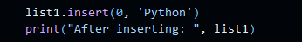

- Run the program to check the output of the above code.

- Removing elements:
There are three ways to remove an element from a list.
- If you know the position of the item you want to remove from a list, you can use the del statement.
- The pop() method removes the last item in a list but lets you work with that item after removing it. The term pop comes from thinking of a list as a stack of items and popping one item off the top of the stack. In this analogy, the top of a stack corresponds to the end of a list. You can use pop() to remove an item from any position in a list by including the index of the item you want to remove in parentheses.
- If you only know the value of the item you want to remove, you can use the remove() method.

- Under the root directory, create a file List_remove.py and type the following code.

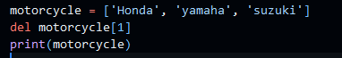
- Run the program to check the output of the above code.

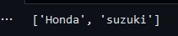

The del used at index 1 deletes the value ‘yamaha. ' After using the del statement, you can no longer access the value removed from the list.

- Add the code below to the same file. -

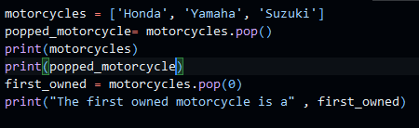

- Run the program to check the output of the above code

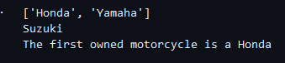

The pop() function takes a value from the list and stores it in the variable ‘popped_motorcycle’. The list is printed to show that a value has been removed. Then, the popped value is printed to prove that the removed value can still be accessed. The output shows that the value ‘suzuki’ was removed from the end of the list and is now assigned to the variable ‘popped_motorcycle.’

- Add the code below in the same file:

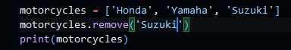

- Run the program to check the output of the above code.

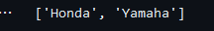

The code removes “Ducati” from the list. You can use the remove() method to work with a value that's being removed from a list.

- Using Loop in Lists
Let’s print out all list elements using the ‘for’ loop.

- Create a file replaceNegative.py and enter the following code:

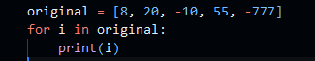

The range() function causes Python to start counting at zero and stop when it reaches the length of the list. The len() function calculates the length of the list. The i consists of the range index used to navigate the list. If the value in the list is less than 0, it is converted to an absolute value and returned to the list.

- Run the program to check the output of the above code.

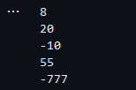

Edit the program to replace negative numbers in the list with positive ones.

Expected result:

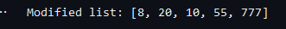

Hint: you can use the abs() function to turn negative numbers into positive numbers

- Tuples
A tuple is a sequence of immutable Python objects. The tuple data type is similar to a list, but with a key difference: tuples are typed with parentheses and cannot be modified, appended, or removed. The following is how tuples look.

tup1 = ('physics', 'chemistry', 1997, 2000);

- Creating, accessing, and updating values

- Create a tuple.py file to define a tuple with multiple data types and try to modify the grade by assigning a 4.0 value to the item at index 1, which is 2.0

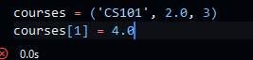

Note that you will get error messages because Tuples can’t be modified, unlike lists.

- Run the program to check the output of the above code.

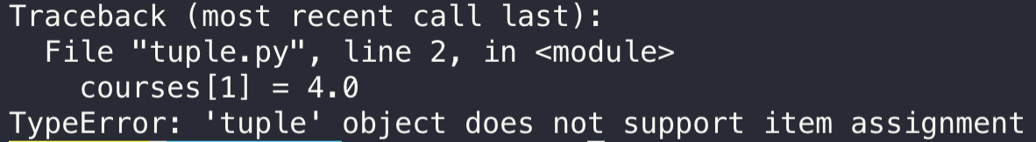

For simple errors like this, it is easy to identify the issue. However, as applications grow more complex, error messages become verbose and harder to interpret. Using an LLM chat agent can help understand why errors occur, but this approach is not foolproof. You must verify that responses are reasonable, as LLMs often tend to rewrite entire applications instead of identifying simple fixes.

- Sorting values

- Create a sortTuple.py with the following code to sort tuples by their first value.

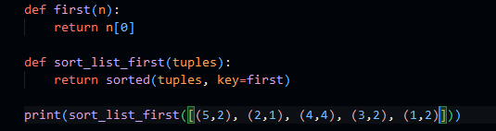

- Run the program to check the output of the above code. The output will be sorted out.

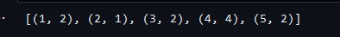

“def” is the function, which will be explained in later chapters. The sorted function takes a keyword argument called key. The key provides a way to specify a function that returns what you would like for your items sorted by. The function receives an "invisible" argument representing an item in the list and returns a value to serve as the item's "key" for sorting.

- Next, let's change how the first function works. The function first takes as an argument, a tuple, and returns the first “0” element. Now, change the function so that it returns to the second element and see how that affects the sorted list. Consider what would happen if a tuple had only one element. Change the index in the function first to return n[1]. Let's do this one more time. Before you run the code, think about what the outcome will be.

As you probably guessed, you got an error message. This is a straightforward fix to see what AI chat agent of choice says about the issue?

Push your work to GitHub
- Go to Source Control on your GitHub Code space and observe the pending changes.

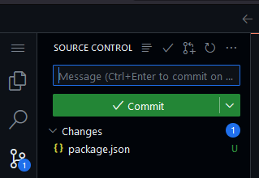

- Type the message for your changes in the message box at the top.
  - For example,” Submission for Module04 – Your Name”

- Click on the dropdown beside the commit button and select “Commit & Push” to update the changes to your repository main branch.

- Select Yes when prompted.

